SIMATS ENGINEERING (SAVEETHA SCHOOL OF ENGINEERING)
Department of Computer Science and Engineering
CO1 ASSESSMENT TOOL 2 – Agile Sprint Planning & User Story Workshop

Course Code: | CSA10 / CSA1063 | Course Title: | Software Engineering
CO Assessed: | CO1 | Assessment: | Assessment Tool 2 – Agile Sprint Planning & User Story Workshop
Weightage: | 20% | Total Marks: | 25
CO1 Statement: | Apply advanced methodologies and agile project management techniques to manage software projects effectively
Student Name: | K V CHARAN TEJA | Reg. No.: | 192424167
Date: | 27-0-2026 | Duration: | 60 minutes

Code of Conduct
I __________________________ (Name / Reg No) certify that this submission is my original work and that I have adhered to the guidelines specified for this assessment. I understand that any violation of academic integrity rules will result in disciplinary action.
Signature of the Student: _________________________

Annexure A – Agile Sprint Planning & User Story Workshop
Instructions to Students:
Each student is assigned an individual software project problem statement. Based on the given problem statement, perform an Agile Sprint Planning and User Story Workshop by applying Agile software engineering practices. Prepare a comprehensive sprint planning document covering the following aspects:
Based on the given problem statement, perform an Agile Sprint Planning and User Story Workshop by applying Agile software engineering practices. Prepare a comprehensive sprint planning document covering the following aspects:
- Identify the Project Vision and Stakeholders
  - Define the project's vision, objectives, and identify all key stakeholders involved.
- Create Epics and User Stories
  - Break down the requirements into Epics and formulate well-structured User Stories using the format:
As a <user>, I want <feature>, so that <benefit>.
- Define Acceptance Criteria
  - Write clear and measurable acceptance criteria for each selected user story using the Given–When–Then format or equivalent.
- Prioritize the Product Backlog
  - Organize and prioritize the product backlog based on business value, customer needs, and project dependencies.
- Plan the Sprint Backlog
  - Select high-priority user stories for the first sprint and divide them into actionable development tasks.
- Estimate Effort Using Story Points
  - Assign story points to each selected user story using an appropriate estimation technique (e.g., Fibonacci sequence or Planning Poker) and justify your estimates.
- Present the Sprint Goal and Expected Deliverables
  - Define a clear sprint goal and describe the expected sprint deliverables, including the features to be completed at the end of the sprint.

Domain: Banking & Finance
Project: Blockchain-Based Secure Banking Transaction Management System

Agile Sprint Planning & User Story Workshop
Blockchain-Based Secure Banking Transaction Management System
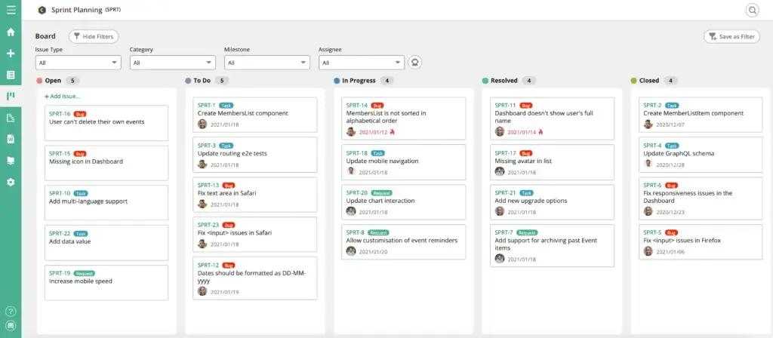
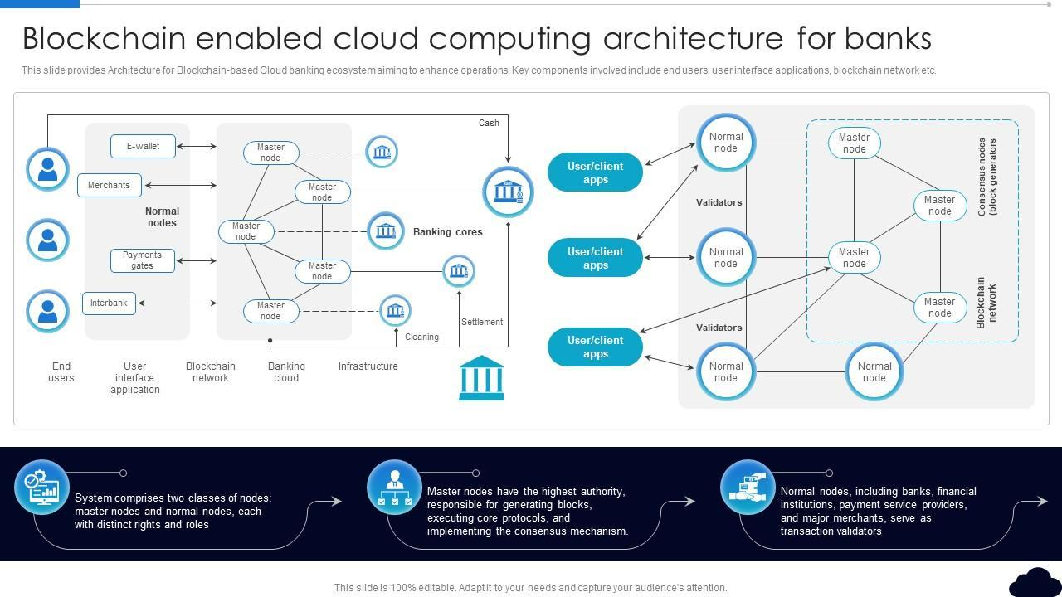
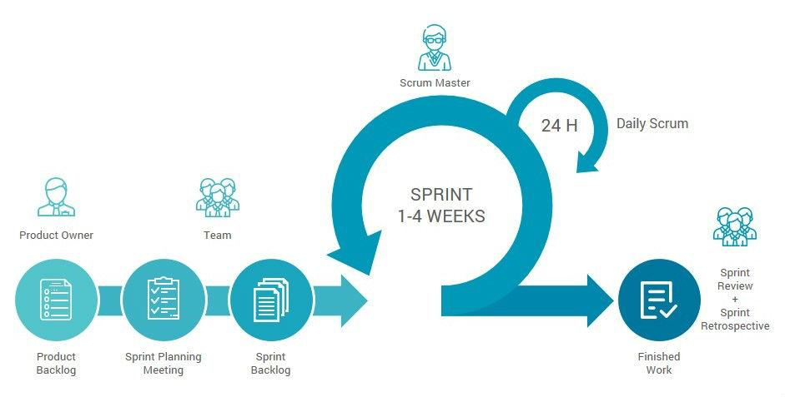
4

1. Project Vision
Vision Statement
The vision of the Blockchain-Based Secure Banking Transaction Management System is to develop a secure, transparent, decentralized, and fraud-resistant banking platform using blockchain technology. The system ensures secure financial transactions, immutable transaction records, faster payment processing, and enhanced customer trust while reducing cyber threats and operational costs.

Project Objectives
- Develop a decentralized banking system.
- Secure all banking transactions using blockchain.
- Prevent fraud and unauthorized access.
- Enable real-time transaction verification.
- Protect customer financial information.
- Improve transparency and accountability.
- Automate transaction validation using smart contracts.
- Provide 24×7 secure online banking services.

Stakeholders
Stakeholder | Role
Customer | Performs banking transactions
Bank Employee | Verifies customer requests
Bank Manager | Monitors banking activities
System Administrator | Maintains the system
Blockchain Validators | Validate transactions
Cyber Security Team | Protects against attacks
Government Authorities | Regulatory compliance
Financial Institution | Banking operations

Banking Stakeholders


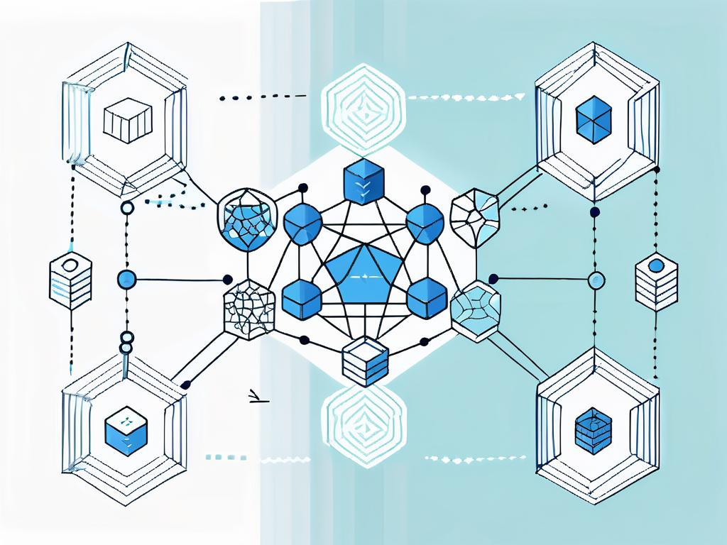

2. Epics & User Stories
Epic 1 – Customer Account Management
User Story 1
As a customer, I want to register an account so that I can access secure banking services.
User Story 2
As a customer, I want to log in using multi-factor authentication so that my account remains secure.

Epic 2 – Banking Transactions
User Story 3
As a customer, I want to transfer money securely so that transactions are completed safely.
User Story 4
As a customer, I want to view my transaction history so that I can monitor all financial activities.

Epic 3 – Blockchain Security
User Story 5
As a blockchain validator, I want to verify transactions so that fraudulent activities are prevented.
User Story 6
As a system administrator, I want every transaction stored in an immutable blockchain ledger so that records cannot be modified.

Epic 4 – Fraud Detection
User Story 7
As a bank manager, I want suspicious transactions to be detected automatically so that fraud can be prevented.

Epic 5 – Reporting
User Story 8
As an administrator, I want to generate audit reports so that regulatory compliance can be maintained.

Agile User Story Workflow
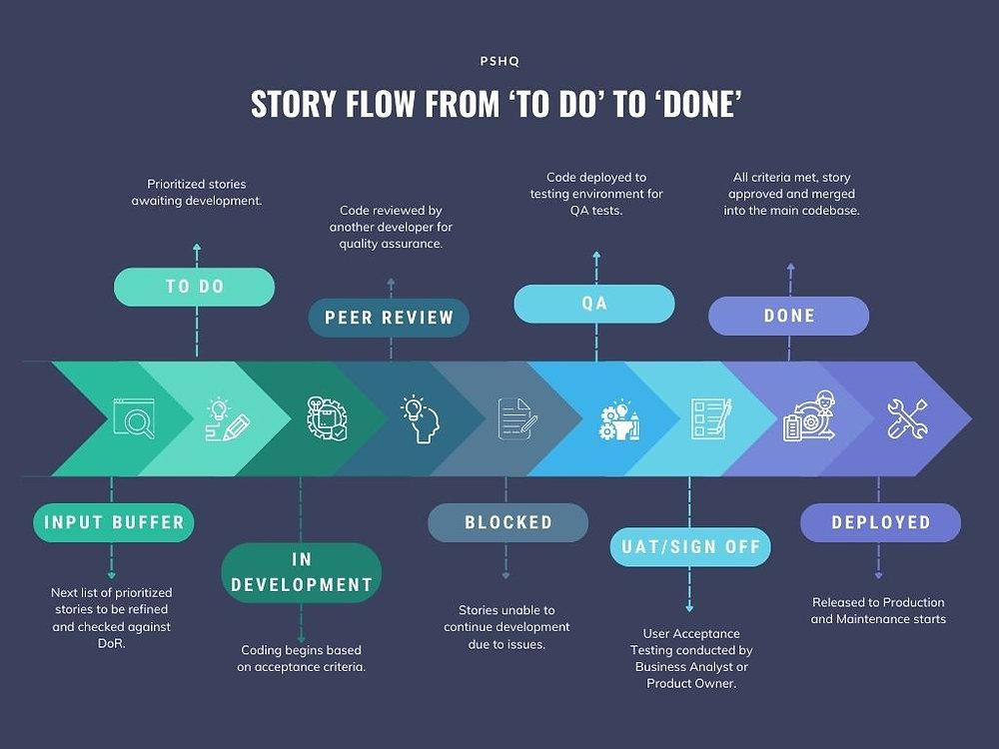
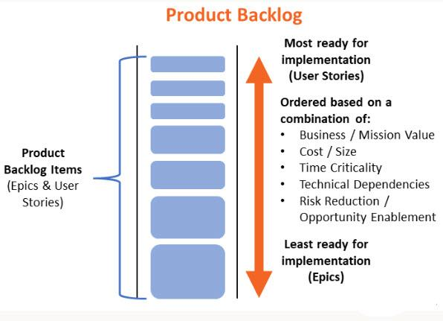
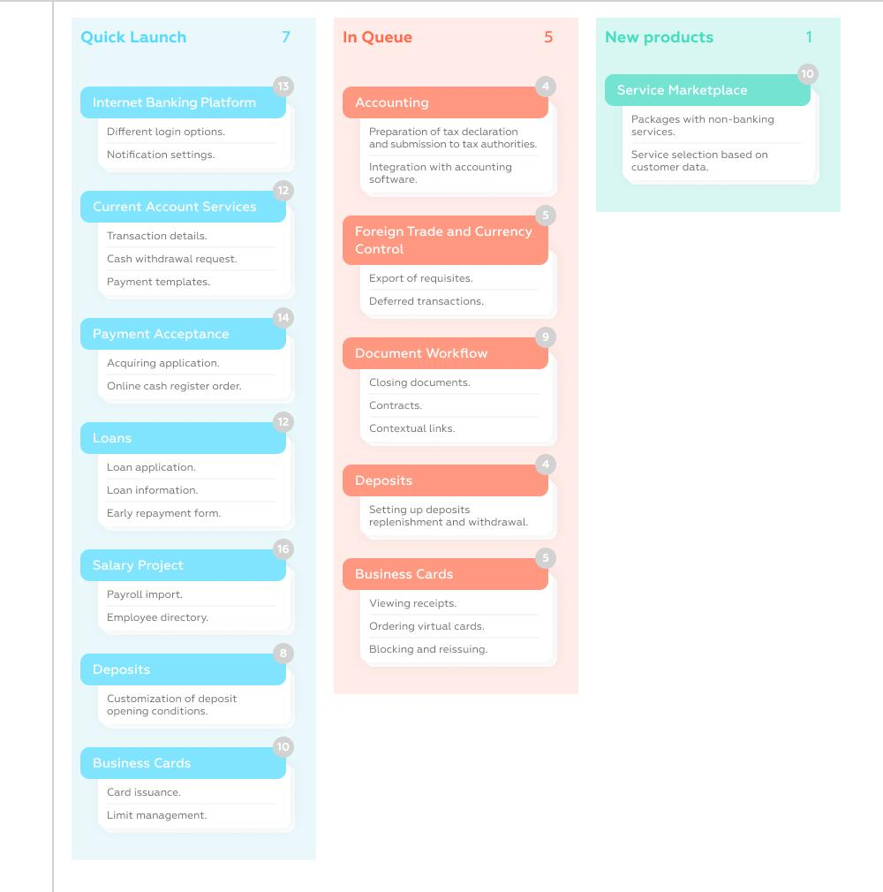

3. Acceptance Criteria
User Story 1
Given
The customer opens the registration page.
When
The customer enters valid personal details.
Then
The account should be created successfully.

User Story 2
Given
The customer enters login credentials.
When
OTP verification is successful.
Then
The customer should access the dashboard.

User Story 3
Given
The customer has sufficient balance.
When
The customer initiates a transfer.
Then
The blockchain validates the transaction and updates both accounts successfully.

User Story 4
Given
The customer opens transaction history.
When
The request is submitted.
Then
All previous blockchain transactions should be displayed.

User Story 5
Given
A transaction is created.
When
Blockchain validators verify the transaction.
Then
The transaction should be permanently stored in the blockchain ledger.

4. Product Backlog
Priority | Product Backlog Item
High | Customer Registration
High | Secure Login
High | Blockchain Validation
High | Fund Transfer
High | Smart Contracts
Medium | Transaction History
Medium | Fraud Detection
Medium | Notifications
Low | Audit Reports
Low | Analytics Dashboard

Product Backlog
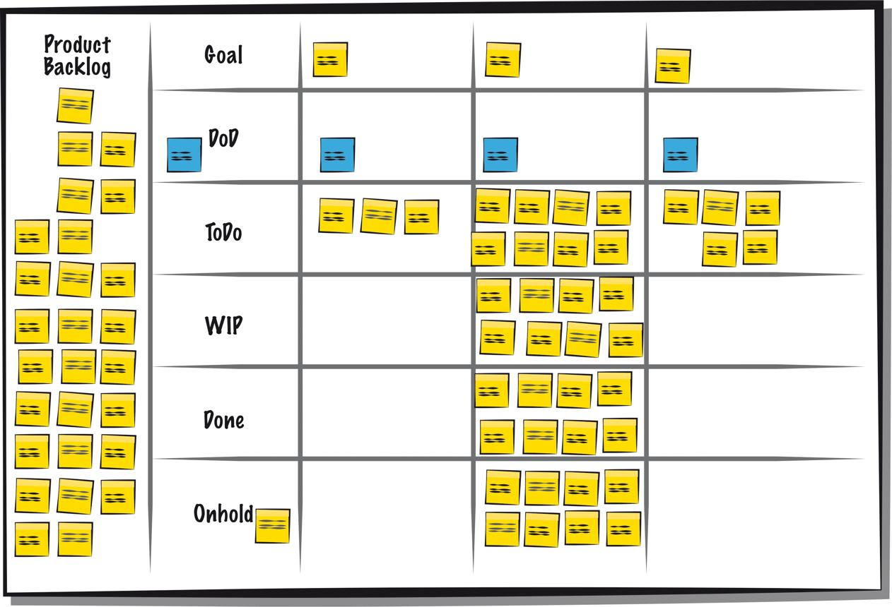
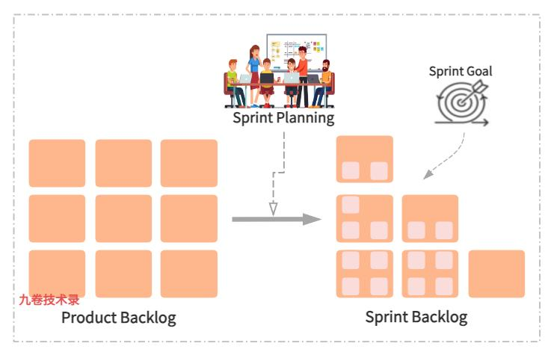
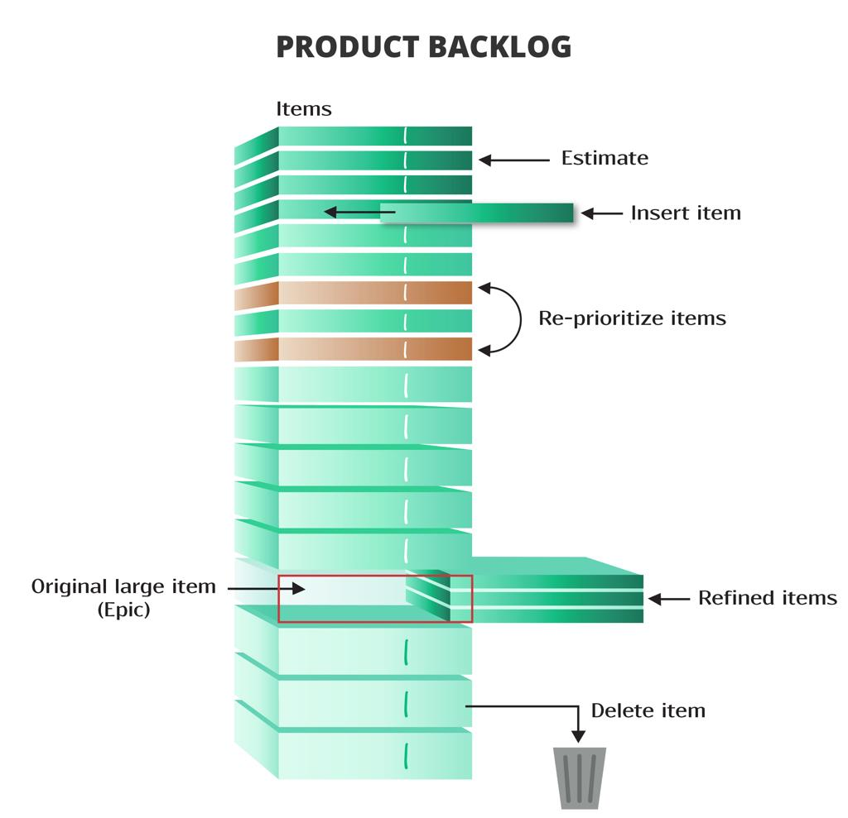

5. Sprint Backlog (Sprint 1)
Task | Assigned Team
Design UI | Frontend Team
Customer Registration | Backend Team
Login Authentication | Backend Team
Blockchain Integration | Blockchain Team
Smart Contract Development | Blockchain Team
Database Design | Database Team
API Development | Backend Team
Testing | QA Team

Sprint Duration
2 Weeks (14 Days)

Sprint Tasks
- UI Design
- Login Module
- Registration Module
- Blockchain Setup
- Smart Contract Creation
- Transaction Module
- API Development
- Unit Testing

Scrum Sprint Planning


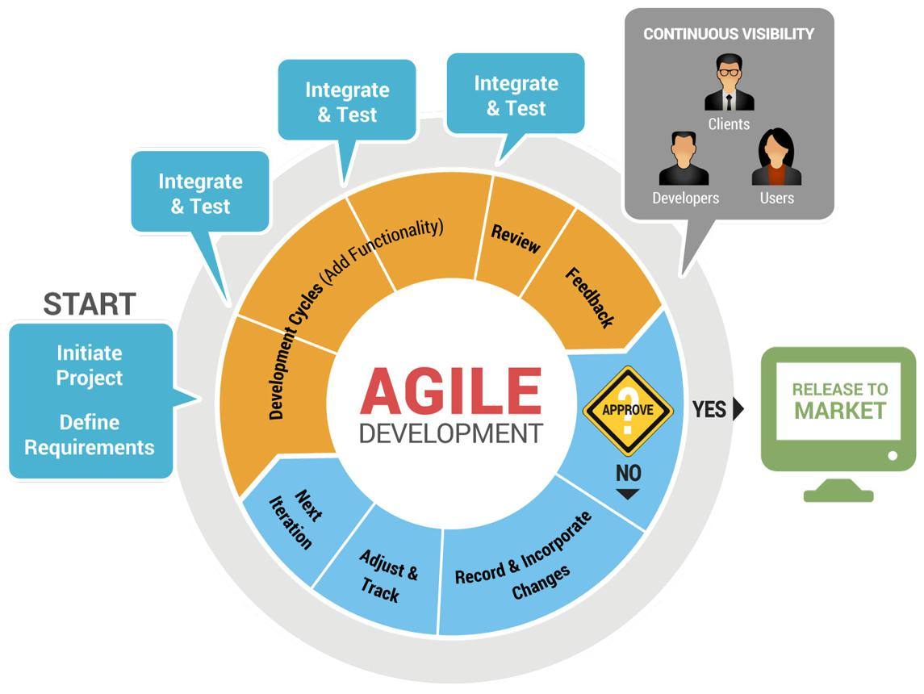
6

6. Story Point Estimation
Using Fibonacci Estimation
User Story | Story Points | Justification
Registration | 3 | Simple
Login | 5 | Security Implementation
Fund Transfer | 8 | Blockchain Validation
Transaction History | 3 | Medium Complexity
Smart Contracts | 13 | High Complexity
Fraud Detection | 8 | AI & Security Logic
Reports | 5 | Moderate Complexity

Total Story Points
45 Story Points

Agile Story Points
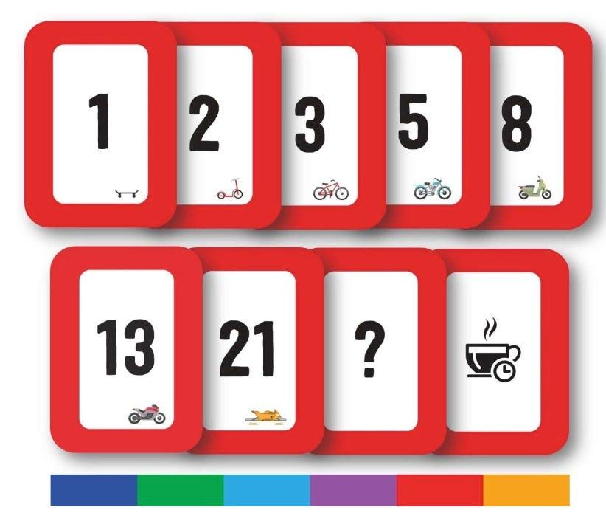



7. Sprint Goal
Sprint Goal
Develop the core modules of the Blockchain-Based Secure Banking Transaction Management System, including customer registration, secure login, blockchain integration, smart contract execution, and secure fund transfer functionality.

Expected Sprint Deliverables
- Customer Registration Module
- Secure Login Module
- Blockchain Network Setup
- Smart Contract Module
- Fund Transfer Module
- Blockchain Transaction Ledger
- Database Design
- REST APIs
- Unit Testing Report
- Sprint Review Document

Final Banking Solution
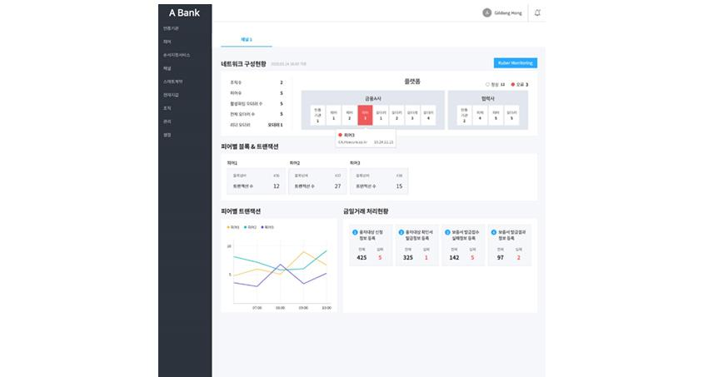
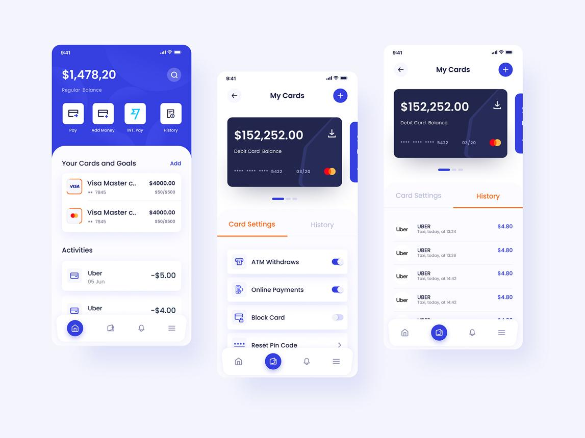


Rubrics for Calculation
Criteria | Excellent (5 Marks) | Good (3 Marks) | Satisfactory (2 Marks) | Needs Improvement (1 Mark)
Project Vision & Stakeholder Identification | Project vision is clear, comprehensive, and aligned with the problem statement. All relevant stakeholders and their roles are correctly identified. | Vision is clear with minor omissions. Most stakeholders are correctly identified. | Vision is partially defined. Some stakeholders are missing or incorrectly identified. | Vision is unclear or incomplete. Stakeholders are poorly identified or missing.
Epics & User Stories | Epics are well-defined and user stories are complete, follow Agile format, and fully capture functional requirements. | Epics and user stories are mostly complete with minor formatting or requirement issues. | User stories are partially complete with limited Agile structure. | User stories are incomplete, unclear, or do not follow Agile practices.
Acceptance Criteria | Acceptance criteria are specific, measurable, testable, and aligned with all user stories. | Acceptance criteria are mostly clear and testable with minor gaps. | Acceptance criteria are partially defined and lack clarity or completeness. | Acceptance criteria are missing or not aligned with user stories.
Product Backlog Prioritization & Sprint Planning | Product backlog is logically prioritized, sprint backlog is realistic, and task breakdown is complete. | Backlog prioritization and sprint planning are mostly appropriate with minor issues. | Prioritization or sprint planning is partially complete with limited justification. | Backlog prioritization and sprint planning are poorly organized or incomplete.
Story Point Estimation, Sprint Goal & Presentation | Story point estimation is well justified, sprint goal is clear, deliverables are realistic, and presentation is professional and well organized. | Estimation and sprint goal are mostly appropriate with minor inconsistencies. Presentation is clear. | Estimation or sprint goal lacks justification. Presentation is adequate but incomplete. | Estimation is unrealistic or missing. Sprint goal, deliverables, and presentation are unclear or incomplete.

Criteria | Mark
Project Vision & Stakeholder Identification | /5
Epics & User Stories | /5
Acceptance Criteria | /5
Product Backlog Prioritization & Sprint Planning | /5
Story Point Estimation, Sprint Goal & Presentation | /5
TOTAL | /25

